July 1 Assessment

Question 1

import java.util.Arrays;

public class ChangeValidNumQ1 {

    public static void main(String[] args) {

        // Input : arr[] = {2, 2, 0, 4, 0, 8}

        // Output : 4 4 8 0 0 0

        int[] array_of_integers = { 2, 2, 0, 4, 0, 8 };

        int[] new_array = new int[6];

        int invalid = 0, count = 0;

        System.out.println("=================================");

        System.out.println("Original Array: " + Arrays.toString(array_of_integers));

        System.out.println("=================================");

        for (int i = 0; i < array_of_integers.length - 1; i++) {

            if (array_of_integers[i] != 0 && array_of_integers[i] == array_of_integers[i + 1]) {

                array_of_integers[i] *= 2;

                array_of_integers[i + 1] = invalid;

                i++;

            }

            // new_array[i] = array_of_integers[i];

        }

        // Step 5: Push all the zeros at the end of 'arr[]'

        for (int j = 0; j < array_of_integers.length; j++) {

            if (array_of_integers[j] != invalid) {

                new_array[count] = array_of_integers[j];

                count++;

            }

        }

        new_array[count] = invalid;

        System.out.println("=================================");

        System.out.print("Modified Array: " + Arrays.toString(new_array));

    }

}

// STEP 1: Traverse the array from 0 to n-1(inclusively).

// STEP 2: Check if arr[i] is not equal to 0 and arr[i]==arr[i+1](next value is

// same as current value).

// STEP 3: If true, then make the current value twice of the self.

// STEP 4: Update next element as 0 and do i++.

// STEP 5: Traverse the array from i = 0 to n-1(step of shifting all the zeroes

// to the end).

// STEP 6: Check if arr[i] != 0.

// STEP 7: Arr[count]=arr[i] and do count++.

// STEP 8: From the traversal of till count is less than n.

// STEP 9: Arr[count]=0 and do count++.

// STEP 10: Print the array.

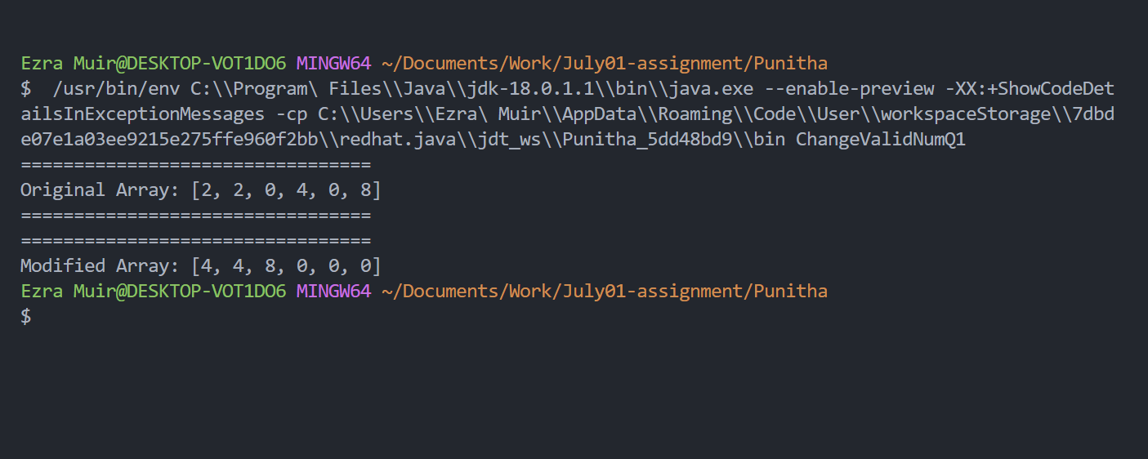

Question 2

import java.util.Scanner;

public class TwistedPrimeQ2 {

    public static void main(String[] args) {

        int number, reverse, sum = 0, flag;

        Scanner scanner = new Scanner(System.in);

        System.out.println("Enter the prime number?");

        number = scanner.nextInt();

        while (number != 0) {

            reverse = number % 10;

            sum = sum * 10 + reverse;

            number = number / 10;

        }

        flag = 0;

        for (int j = 2; j <= sum / 2; j++) {

            if ((sum % j) == 0) {

                flag = 1;

                break;

            }

        }

        if (flag == 0) {

            System.out.println("This number is a twisted Prime");

        } else {

            System.out.println("This number is not a Twisted Prime");

        }

        scanner.close();

    }

}

// STEP 1: START

// STEP 2: DEFINE number, reverse, flag

// STEP 3: SET sum = 0

// STEP 4: ENTER number

// STEP 5: REPEAT STEP 6 to 8 UNTIL (n!=0)

// STEP 6: reverse = number%10

// STEP 7: sum = sum*10 + reverse

// STEP 8: number = number/10

// STEP 9: SET flag = 0

// STEP 10: REPEAT STEP 11 UNTIL j<=sum/2

// STEP 11: if(sum%j)==0

// then

// set flag = 1

// break

// STEP 12: if(flag==0)

// then PRINT "yes"

// else

// PRINT "no"

// STEP 13: END

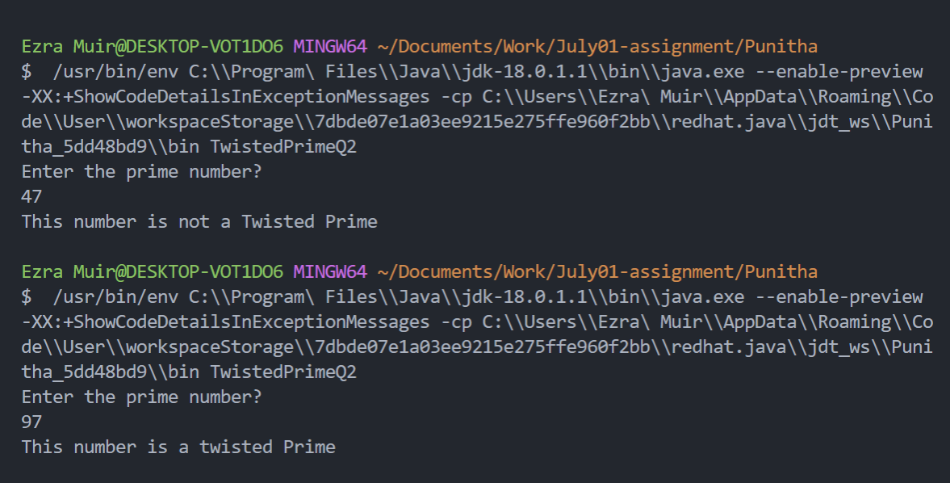

Question 3

public class SocksPairQ3 {

    public static void main(String[] args) {

        int[] array_of_socks = { 1, 2, 1, 2, 1, 3, 2 };

        int count = 0, color;

        for (int i = 0; i < array_of_socks.length; i++) {

            for (int j = i + 1; j < array_of_socks.length; j++) {

                if (array_of_socks[i] == array_of_socks[j]) {

                    count++;

                }

            }

            if (count == 2) {

                color = array_of_socks[i];

                // System.out.println("Color " + color + " is repeated " + count + "times");

                System.out.println("Color " + color + " is a " + "pair");

            }

            count = 0;

        }

    }

}

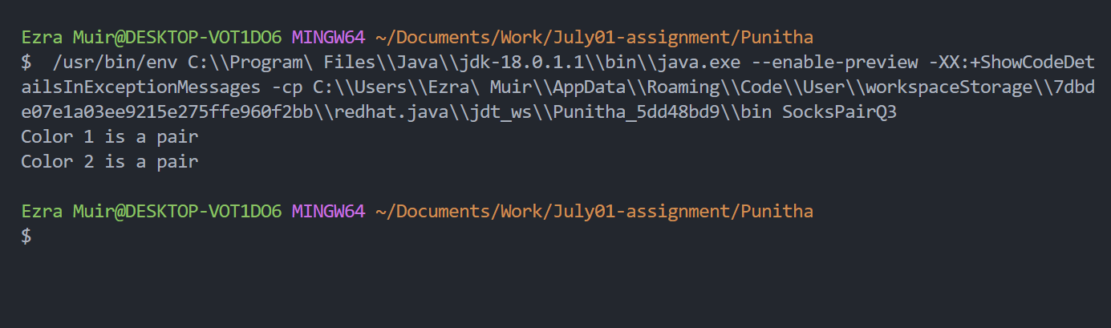

Question 4

import java.util.Arrays;

public class EvenBeforeOddQ4 {

    public static void main(String[] args) {

        int i = 0;

        int[] even_and_odd = { 1, 7, 8, 5, 7, 13, 0, 2, 4, 9 };

        System.out.println("========================================================");

        System.out.println("Original array: " + Arrays.toString(even_and_odd));

        while (i < even_and_odd.length && even_and_odd[i] % 2 == 0) {

            i++;

        }

        for (int j = i + 1; j < even_and_odd.length; j++) {

            if (even_and_odd[j] % 2 == 0) {

                int temp = even_and_odd[i];

                even_and_odd[i] = even_and_odd[j];

                even_and_odd[j] = temp;

                i++;

            }

        }

        System.out.println("========================================================");

        System.out.println("New Array: " + Arrays.toString(even_and_odd));

        System.out.println("========================================================");

    }

}

